Promoted for and behalf of Cycling Time Trials under their rules and regulations
Sussex Cyclists’ Association
Founded 1921

25 Mile Time Trial – Sunday 7th May 2023 – Course G25/93
Incorporating Sussex 25 miles Championship

Event Secretary Timekeepers
Steve Dennis (East Grinstead CC) Start: Mr Richard Blackmore (East Grinstead CC)
15 Sherwood Walk, Crawley, W. Sussex Finish: Mr Mick Irons (Worthing Excelsior CC)
RH10 6NQ
Tel: 01293 522721 – Mob: 07778 548979
E-mail: carla.dennis@sky.com

Prizes

1st Man (TT bike & Road bike) £30 1st Woman (TT bike & Road bike) £30
2nd Man (TT bike & Road bike) £20 2nd Woman (TT bike & Road bike) £20
3rd Man (TT bike only) £10 3rd Woman (TT bike only) £10

1st Vet £15 1st Male Team of 3 £10 each
2nd Vet £10 1st Female Team of 3 £10 each

Sussex Championship awards for affiliated riders

Fastest overall Boniface Cup. Highest plus on CTT target time Horry Hemsley Cup. Fastest team of three Lee Memorial Shield. Medals are also awarded to each team member and individual riders in the following categories: Overall, Veteran on CTT Target Times, Women, Juniors and Juveniles subject to the number of entries in each category. All Championship trophies and medals will be presented at the Annual Prize Presentation ceremony.

Headquarters

Steyning Centre Fletcher’s Croft, Steyning, BN44 3XZ
Open from 6:00 am.

OS Landranger sheet 198, grid ref TQ178 113
Google Maps Streetview link http://goo.gl/maps/hkLKe

Directions and car parking

Coming from the north: A24 / A283 Coming from the South: A27 / A283.
Turn right into Horsham Road and proceed on to Second left off Bramber roundabout. Proceed up Clays
Steyning High Street. At the mini roundabout turn left Hill and continue on to Steyning High Street. At the mini
(NE) and proceed along Church Street pass the library & roundabout turn right (NE) and proceed along Church
church, turn right into Steyning Centre. Street pass the library & church, turn right into Steyning
Centre.

Ample car parking is available at the Steyning Centre
Please do not wear cleated cycling shoes in the Hall. Thank you.
Promoted for and behalf of Cycling Time Trials under their rules and regulations
Sussex Cyclists’ Association
Founded 1921

25 Mile Time Trial – Sunday 7th May 2023 – Course G25/93
Incorporating Sussex 25 miles Championship

Race Numbers Warming up and to the Start

Numbers will be available at the event HQ. Please Competitors are requested not to warm up on the course
collect your number when you sign on. after the event has started.

Notice of any additional hazards to be aware of on the Left out of the car park to the mini roundabout, then right
course will be displayed next to the signing on sheet. onto the High Street. Proceed North to the A283 junction.

After the event please return your race number to the Left and then immediate right on to B2135 for 0.4 miles.
event HQ in exchange for a cup of tea or coffee.

DON’T FORGET YOUR FRONT AND REAR LIGHT AND HELMET. REMEMBER TO SIGN OUT AFTER YOUR RIDE!

.
Please pay attention to the following Safety Notes

London South District Regulation: No vehicles, except those of the timekeepers and race officials, shall be parked in the vicinity of the start or finish areas.

CTT regulations require that all competitors must wear a properly affixed helmet which must be of hard/soft shell construction. Helmets should conform to internationally accepted safety standards.

Competitors Machines: must have working front and rear lights, either flashing or constant, fitted to their machine in a position clearly visible to other road users and is active while the machine is in use.

Please be aware that there has been road works on the course, and the event may have to use an emergency course.

Course details G25/93 Distance

START on B2135 just south of entrance to Wappingthorpe Manor (Map ref TQ 172131). 0.0

Proceed north on the B2135 through Partridge Green to junction with A24. (M) 6.708

Turn left and proceed southwards on the A24 to Washington RBT. (M) 12.519

Turn left on A283 and proceed east, via Bramber and Beeding Court RBT (M) to Turn at Adur
Bridge RBT.(M) 20.987

Retrace on A283 via Beeding Court and Bramber RBTs to Finish at paint mark on curb opposite
TP3 about 25 yards before Canons Way. (Map ref TQ 181118). 25.00

Course details can be viewed or downloaded from the SCA website at the link www.sussexca.org.uk/g2593.html

Promoted for and behalf of Cycling Time Trials under their rules and regulations
Sussex Cyclists’ Association
Founded 1921

25 Mile Time Trial – Sunday 7th May 2023 – Course G25/93
Incorporating Sussex 25 miles Championship

TIME TRIAL COURSE - G25/93
Steyning - Partridge Green - West Grinstead - Washington - Shoreham - Steyning - A24 / A283 - B2135
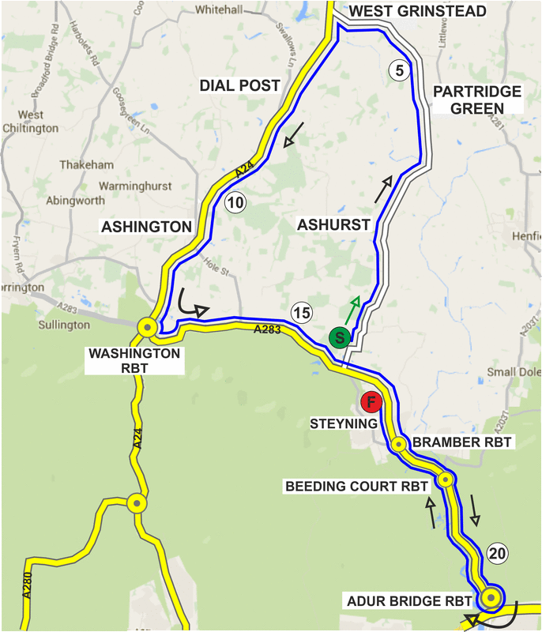

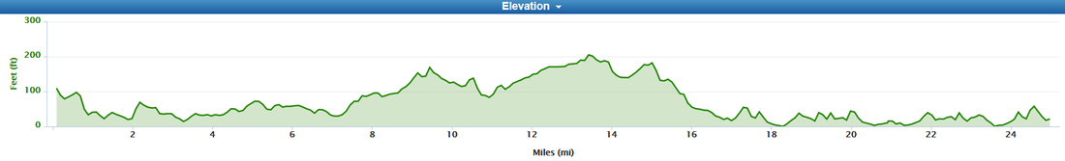

No. | Name | Club | Cat. | Standard | Start
1 | Angela Dyson | East Grinstead CC | WS (RBike) |  | 07.01
2 | Piers Newman | East Grinstead CC | V55 (RBike) | 1.09.45 | 07.02
3 | Anna Roe | East Grinstead CC | WS (RBike) |  | 07.03
4 | Russel Cottingham | East Grinstead CC | V40 (RBike) | 1.02.30 | 07.04
5 | Rob Smith | Village Cycle Club | V51 (RBike) |  | 07.05
6 | Cris Coxon | Brighton Mitre CC | V46 | 1.05.18 | 07.06
7 | Francine Davis | East Grinstead CC | WV55 | 1.13.58 | 07.07
8 | Anita Turner | Eastbourne Rovers CC | WV52 | 1.12.21 | 07.08
9 | Cass Vollmer | East Grinstead CC | WV45 | 1.08.45 | 07.09
10 | Emma O’Toole | District of Hamwick Cyclesport | WS |  | 07.10
11 | Domie Pollard | East Grinstead CC | WV51 | 1.11.50 | 07.11
12 | Peter Horsfield | Redmon CC | V72 | 1.19.00 | 07.12
13 | Simon Craig-McFeely | …a3crg | V64 | 1.14.31 | 07.13
14 | Peter Baker | Lewes Wanderers CC | V65 | 1.15.03 | 07.14
15 | Peter Madarasz | Team TMC | V42 | 1.03.25 | 07.15
16 | Tony Reeves | GS Stella | V51 | 1.07.45 | 07.16
17 | Don Parker | Brighton Mitre CC | V74 | 1.20.10 | 07.17
18 | Ferenc File | Horsham Cycling | S |  | 07.18
19 | Richard Keevil | GS Stella | V54 | 1.09.15 | 07.19
20 | Adrian Blacker | VTTA (Surrey/Sussex) | V59 | 1.11.50 | 07.20
21 | Karl Roberton | Worthing Excelsior CC | V48 | 1.06.16 | 07.21
22 | David Pollard | VTTA (Surrey/Sussex) | V65 | 1.15.03 | 07.22
23 | Chris Lord | Brighton Excelsior CC | V70 | 1.17.51 | 07.23
24 | John Marinko | Brighton Mitre CC | V58 | 1.11.18 | 07.24
25 | David Clark | Eastbourne Rovers CC | V54 | 1.09.15 | 07.25
26 | Ed Jarman | Brighton Excelsior CC | V45 | 1.04.50 | 07.26
27 | Matt Woodhart | Team TMC | V45 | 1.04.50 | 07.27
28 | Chris Pope | East Grinstead CC | S |  | 07.28
29 | Cai Marle-Garcia | East Grinstead CC | S |  | 07:29
30 | Chris Jones | Bynea Cycling Club | V49 | 1.06.45 | 07.30
31 | Kevin Plummer | Team TMC | V57 | 1.10.47 | 07.31
32 | Adam Rogers | Eastbourne Rovers CC | V48 | 1.06.16 | 07.32
33 | Branden Stott | Epsom CC | V49 | 1.06.45 | 07.33
34 | William Appleby | Village Cycle Club | V51 | 1.07.45 | 07.34
35 | Howard Bayley | Blazing Saddles | V48 | 1.06.16 | 07.35
36 | Martin Gibbs | Team TMC | S |  | 07.36
37 | Vince Freemam | Sussex Revolution VC | V43 | 1.03.53 | 07.37
38 | Paul Martin | NAUT Cycling | V52 | 1.08.14 | 07.38
39 | Mike Boyce | …a3crg | V67 | 1.16.10 | 07.39
40 | Nik Allen | Team TMC | V51 | 1.07.45 | 07.40
42 | Pat Wright | Paceline RT | S |  | 07.42
44 | Matthew Smith | Team TMC | S |  | 07.44
46 | Andy Critchlow | Paceline RT | V49 | 1.06.45 | 07.46
48 | Howard Shaw | TrainSharp | S |  | 07.48

